 | International Journal of Mechanical Engineering and Smart Technology  ISSN: xxxx-xxxx (Print) | ISSN: xxxx-xxxx (Online)

Vol. 0, No. 0 (2026) | Page XX–XX | DOI: 10.XXXXX/ijomest.XXXX.XXXX | Received: DD Month YYYY · Accepted: DD Month YYYY

Title of the Article: A Study on [Topic] in Mechanical Engineering and Smart Technology Applications

First Author^{1*}, Second Author², Third Author³
¹ Department of Mechanical Engineering, University Name, City, Country
² Department of Mechanical Engineering, University Name, City, Country
³ Department of Mechanical Engineering, University Name, City, Country
*Corresponding author: Author, email@institution.ac.id

ABSTRACT
The abstract should contain 150–200 words and briefly explain the background, objectives, methods, main findings, and conclusions of the study. Avoid citations, abbreviations, equations, and references inside the abstract. The abstract should clearly demonstrate the novelty and contribution of the study. The writing used is Times New Roman 10 pt, with a spacing of 1.15.

KEYWORDS Mechanical Engineering, Smart Technology, Keyword Three, Keyword Four, Keyword Five

1. INTRODUCTION
This section explains the research background, research problems, urgency of the study, previous studies, research gap, novelty, and objectives of the research. Authors should explain why the topic is important and how the study contributes to the development of science and technology. The introduction should be written systematically and supported by relevant references using IEEE citation style. The writing used is Calibri 10 pt, with a spacing of 1.15.

2. METHODOLOGY
This section explains the research design, materials, equipment, procedures, experimental setup, data collection techniques, and data analysis methods. The method should be written clearly so that other researchers can reproduce the study. If mathematical equations are used, they should be written clearly and numbered sequentially. The writing used is Calibri 10 pt, with a spacing of 1.15.

3. RESULTS AND DISCUSSION
This section presents research findings supported by figures, tables, graphs, and data analysis. The discussion should explain the significance of the findings, comparison with previous studies, and scientific interpretation of the results. Avoid presenting raw data without analysis. The writing used is Calibri 10 pt, with a spacing of 1.15.

This section presents research findings supported by figures, tables, graphs, and data analysis. The discussion should explain the significance of the findings, comparison with previous studies, and scientific interpretation of the results. Avoid presenting raw data without analysis. The writing used is Calibri 10 pt, with a spacing of 1.15.

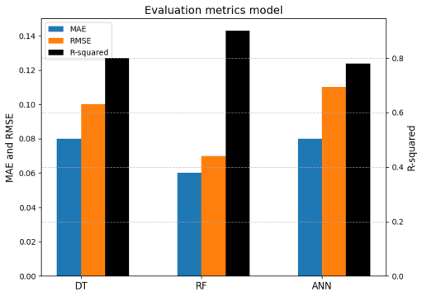
Figure 1. Caption of the figure

An example of using an equation/formula is written as an equation:
$ρ=\frac{\vec{E}}{J_{C}(T=\text{const.})⋅(P⋅{(\frac{\vec{E}}{E_{C}})}^{m}+(1-P))}$ (1)
Table 1. Caption of the table
No | Parameter | Value
1 | Sample Parameter | 00
2 | Sample Parameter | 00
3 | Sample Parameter | 00

4. CONCLUSION
The conclusion should answer the objectives of the research and summarize the important findings. The conclusion should not repeat the discussion and should emphasize the scientific contribution and possible future work. The writing used is Calibri 10 pt, with a spacing of 1.15.

ACKNOWLEDGEMENTS (If any)
Include the names of funding agencies or organizations, grant numbers, project numbers, and any relevant information related to research funding support. The writing used is Calibri 10 pt, with a spacing of 1.15.
AUTHORS’ CONTRIBUTIONS
XX, XX: Conceptualization; Methodology; Supervision; Formal analysis; Validation; Writing – original draft; Writing – review & editing.
XX, XX: Investigation; Data curation; Formal analysis; Visualization; Writing – original draft.
XX, XX: Conceptualization; Methodology; Supervision; Project administration; Writing – review & editing.AUTHOR

INFORMATION AUTHOR
First Author, University, Country
Orcid id
Email: author’s email
Second Author, University, Country
Orcid id
Email: author’s email
Third Author, University, Country
Orcid id
Email: author’s email
Fourth Author, University, Country
Orcid id
Email: author’s email

REFERENCES
The primary references should consist of international journals and conference proceedings. All references must be relevant, recent, and closely related to the research topic. References should be written using IEEE citation style, with a minimum of 12 references from current published research. Authors are encouraged to use reference management software such as Mendeley or Zotero. Please ensure that all references are written consistently according to the format examples below (10 pt):
- Tan, P., Tong, L., & Steven, G. P. (1997). Modelling for predicting the mechanical properties of textile composites—A review. Composites Part A: Applied Science and Manufacturing, 28(11), 903-922.
- Chong, B. W., Othman, R., Putra Jaya, R., Mohd Hasan, M. R., Sandu, A. V., Nabiałek, M., ... & Abdullah, M. M. A. B. (2021). Design of experiment on concrete mechanical properties prediction: a critical review. Materials, 14(8), 1866.
- J. Smith and A. Brown, “Mechanical system analysis,” Journal of Engineering Research, vol. 10, no. 2, pp. 12–18, 2024.
- A. Kumar, Smart Manufacturing Technology. New York: Springer, 2023.
- S. Lee et al., “Artificial intelligence in manufacturing,” International Journal of Manufacturing, vol. 5, no. 1, pp. 100–110, 2022

